**Laboratori a Pagamento : Link per l’iscrizione**

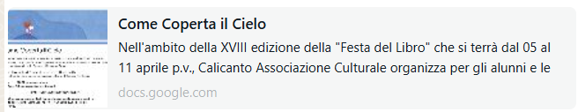 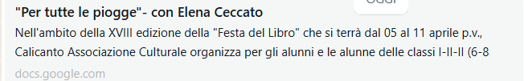

[**https://docs.google.com/forms/d/e/1FAIpQLSf0cdXE31SSfcTUwDqPeIx5Dk_9DGvf54BuaSq-v3D1Jov8Cg/viewform**](https://docs.google.com/forms/d/e/1FAIpQLSf0cdXE31SSfcTUwDqPeIx5Dk_9DGvf54BuaSq-v3D1Jov8Cg/viewform)[**https://docs.google.com/forms/u/1/d/19yLXap-bnxMLxkm_BABoyTC9SC2d9oPJy8pdar73RJM/edit?usp=drivesdk**](https://docs.google.com/forms/u/1/d/19yLXap-bnxMLxkm_BABoyTC9SC2d9oPJy8pdar73RJM/edit?usp=drivesdk)

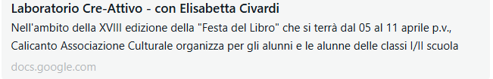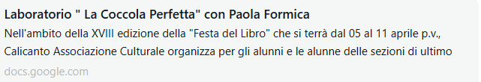

[**https://docs.google.com/forms/u/1/d/1cFzn1gH-eyijyBJ5CwIR9uqSbB0UpNCn-wPRUVqq_FA/edit?usp=drivesdk**](https://docs.google.com/forms/u/1/d/1cFzn1gH-eyijyBJ5CwIR9uqSbB0UpNCn-wPRUVqq_FA/edit?usp=drivesdk) **[https://docs.google.com/forms/u/1/d/1GVk_FfHi0vMg9lFNwD9YzZY8nSK1SwkvzmBLywR-jK4/edit?usp=drivesdk](%20https:/docs.google.com/forms/u/1/d/1GVk_FfHi0vMg9lFNwD9YzZY8nSK1SwkvzmBLywR-jK4/edit?usp=drivesdk)**

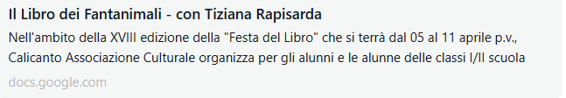 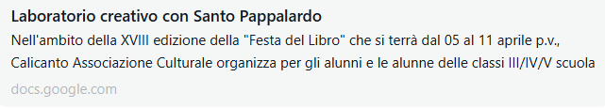

[**https://docs.google.com/forms/u/1/d/1Y2EkUg-L8-AvC6EMZKKjK010Nt1wKZlelcvHzkeOBRU/edit?usp=drivesdk**](https://docs.google.com/forms/u/1/d/1Y2EkUg-L8-AvC6EMZKKjK010Nt1wKZlelcvHzkeOBRU/edit?usp=drivesdk)[**https://docs.google.com/forms/u/1/d/1kwEXw4ThxPrfm4xFrOkGl60tNNUmGxySoljFwx0o8y8/edit?usp=drivesdk**](https://docs.google.com/forms/u/1/d/1kwEXw4ThxPrfm4xFrOkGl60tNNUmGxySoljFwx0o8y8/edit?usp=drivesdk)

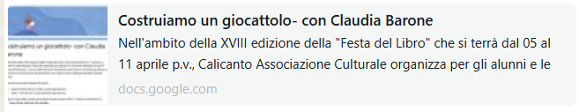

[**https://docs.google.com/forms/u/1/d/12u1W0dc8XGCH1QAZYg7JZfFzIcDMQNufKQU1L661jpY/edit?usp=drivesdk**](https://docs.google.com/forms/u/1/d/12u1W0dc8XGCH1QAZYg7JZfFzIcDMQNufKQU1L661jpY/edit?usp=drivesdk)[**https://docs.google.com/forms/u/1/d/1n9W4DYbFqtg6VR3m0rlovVr7XpZoWBC-pQDrhW0FclQ/edit?usp=drivesdk**](https://docs.google.com/forms/u/1/d/1n9W4DYbFqtg6VR3m0rlovVr7XpZoWBC-pQDrhW0FclQ/edit?usp=drivesdk)